**Reposition Duty Start End Tasks For**

**Breaks**

***Work-flow to Use Reposition Duty Start End Tasks***

***For Breaks***

This preference is accessed through **Load Template**



There is only one template available, and only one instance of it is permitted



***Preference Overview***

If the total duration of the depot pull out plus the following service trip or the service trip plus the following depot pull in are too long, a driver may not be able to commence the trip if work limitations are upheldThis preference allows for repositioning duty start end tasks in order to create a duty that upholds the driver break limitations

***Templates Available from Optibus Reposition Duty Start End Tasks For Breaks* Purpose:**

As stated in the Overview **Prerequisites:** None. **Opening Dialog:**

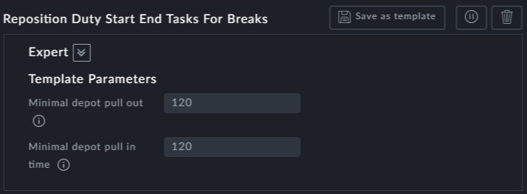

**Point to note:**

**Minimal depot pull out** and **Minimal depot pull in** are the minimum times for these

activities for which repositioning is available.